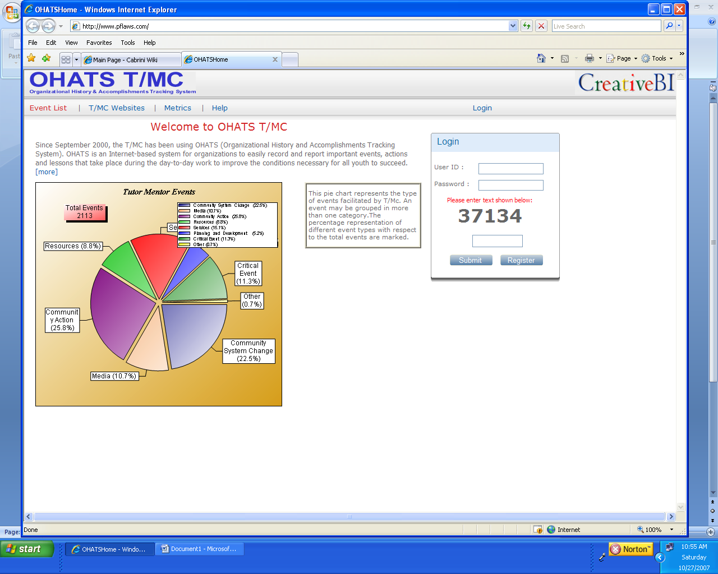
This page looks pretty good. I’d like the opening paragraph to be another inch deeper.
At the bottom of the intro paragraph, add this paragraph and link:
Read this pdf to see how we have intended to summarize and share the information in the OHATS T/MC. http://www.tutormentorexchange.net/OHATS/Reports/TMC_OHATS_Report_Sep-00_thru_Mar-02.pdf
In the HEADINGS bar,
- EVENT LIST - I do not want people who are not logged in to be able to see the list of documented actions. I only want them to see the charts. If you change this to HOME this would bring people who are not logged in back to the home page, but would give people who are logged in, ability to see the list of items documented.

PERMISSIONS,
how do I assign password and give permission to people who are already recorders, from previous years. How do we limit editing permissions? This needs to be working before we go public.

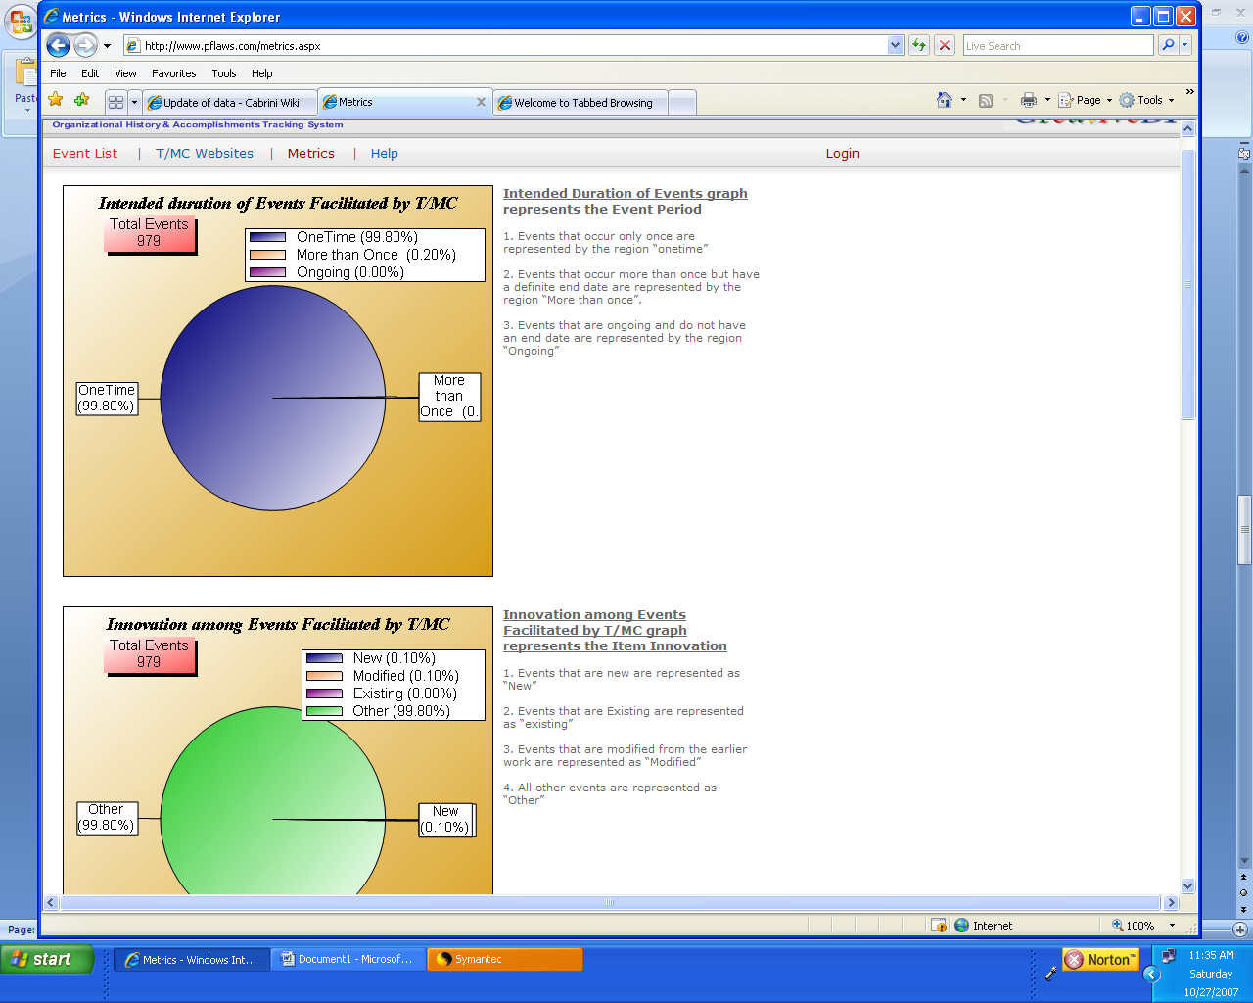
Why are we able to see a pie chart on the Home page, with segmented categories, and not on the METRICS page?
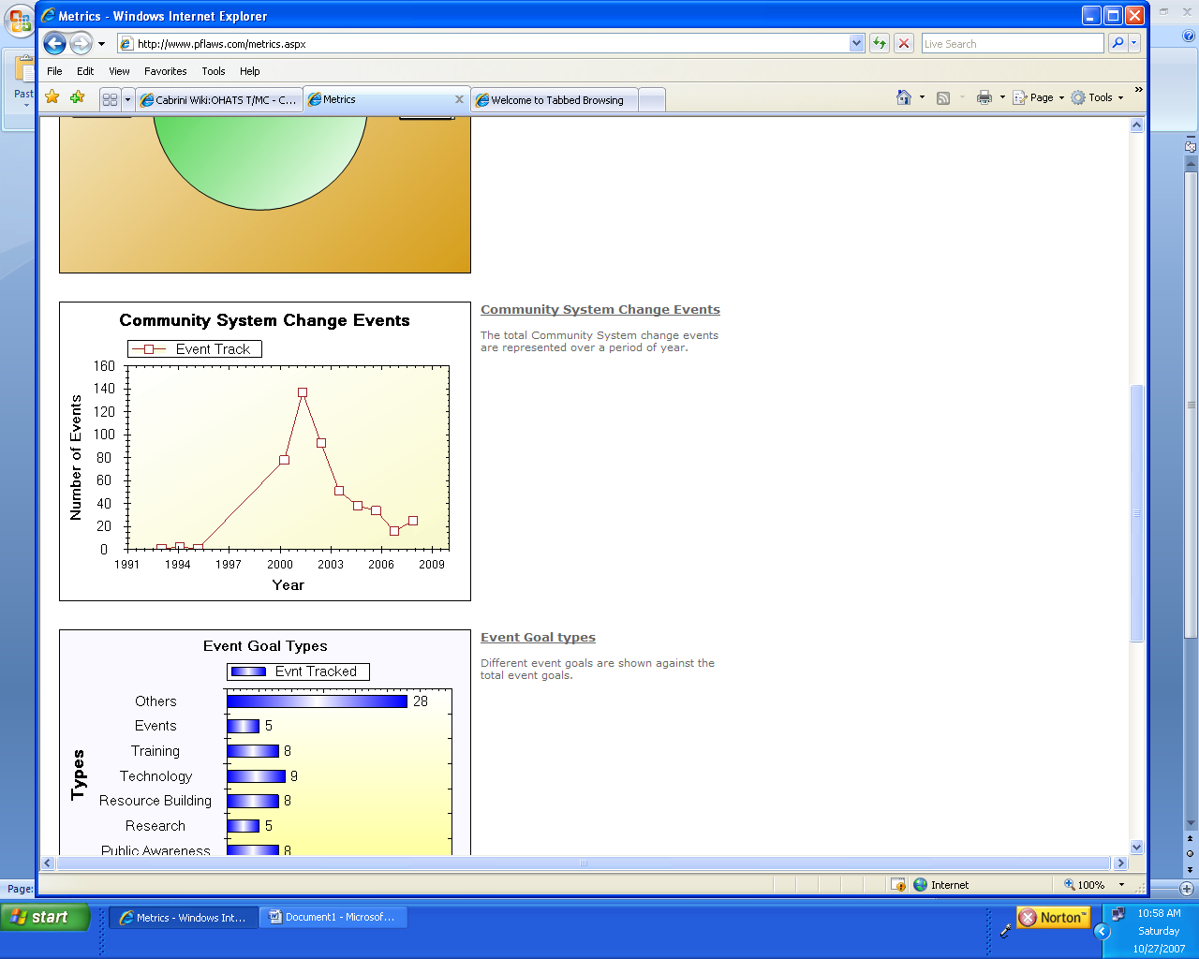
On the community System Change screen we need to be able to add a text overlay to highlight when key events were added, such as conferences. This may be something we do when we have money to pay someone to do this.

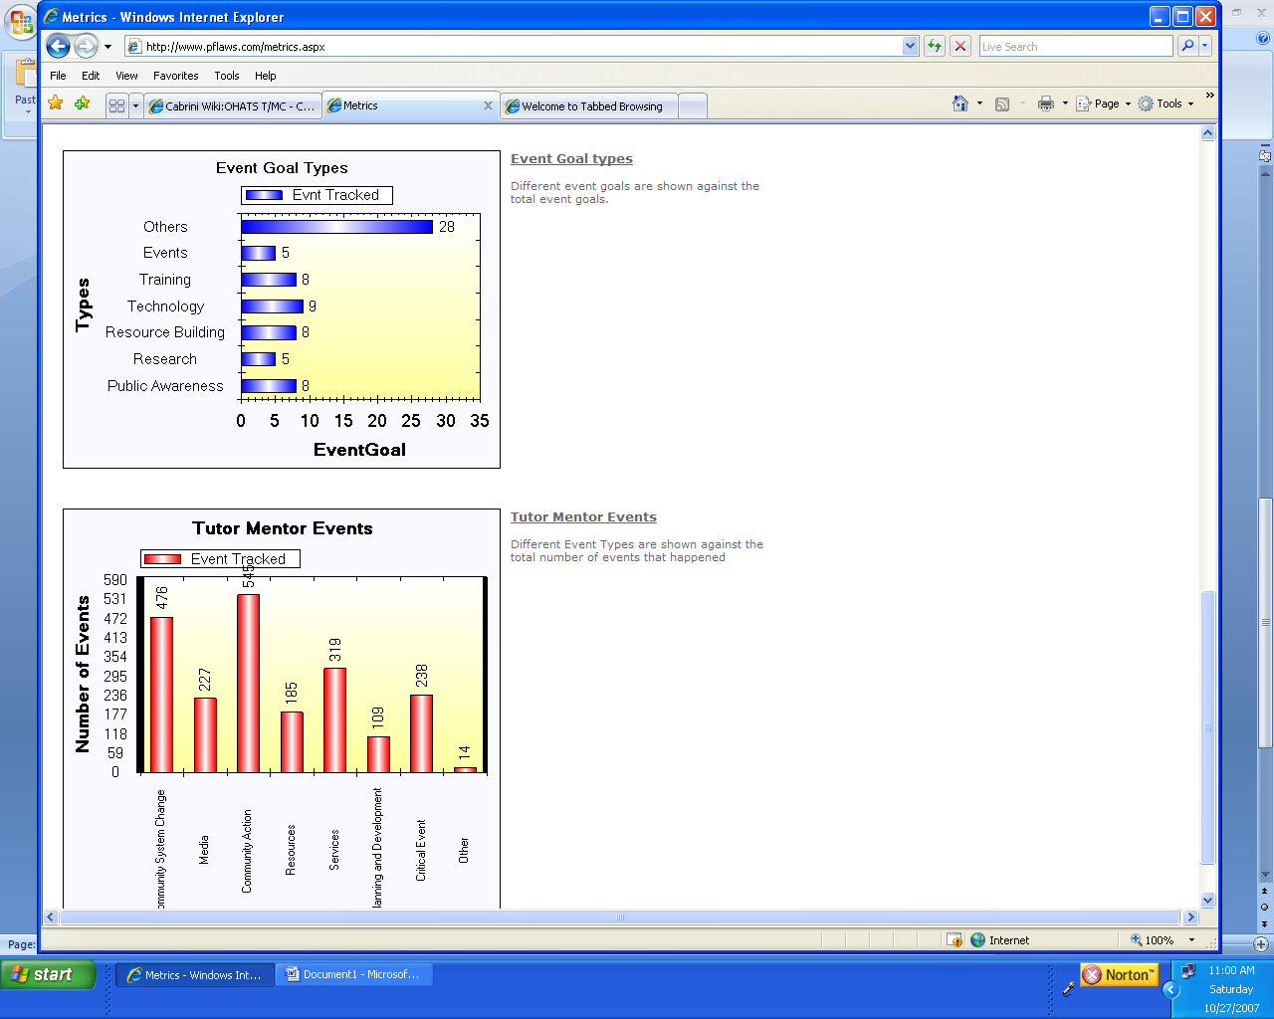
Under Tutor/Mentor events charts I want one more section, with a heading of
Examples of Tutor/Mentor Connection Community Change activities as a result of actions documented:
Include links to - Map Gallery, http://webpages.charter.net/jcory17/geotech/tmc_directory.html - Program Locator, http://www.tutormentorprogramlocator.net/programlocator/default.asp - T/MC links library, http://cmapspublic.ihmc.us/servlet/SBReadResourceServlet?rid=1180119458133_1566509717_34175&partName=htmltext
- endorsements (this is a NEW category of information that we need to code and document. I can go back through the spread sheet to add this. You’ll need to add this to the create event field) . This may be something we need to pay to do.

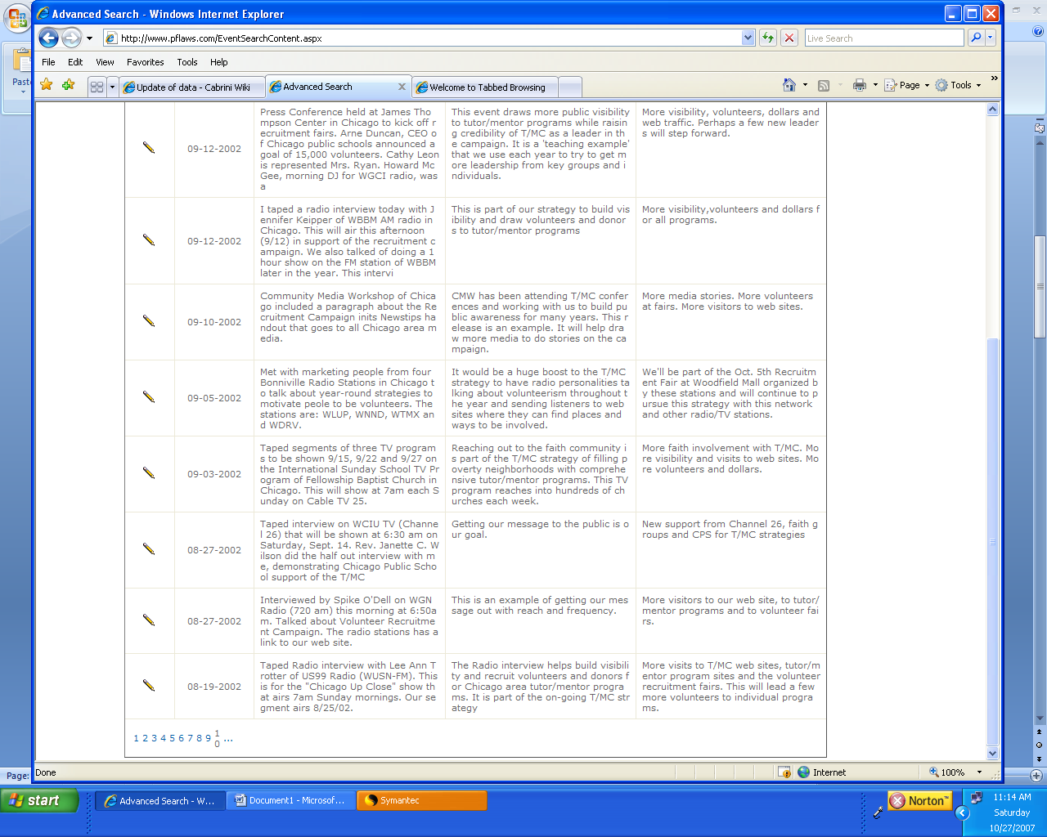
At bottom where you show page numbers, can you add “NEXT 10” or NEXT so you can scroll to more pages
The spacing looks much better now.

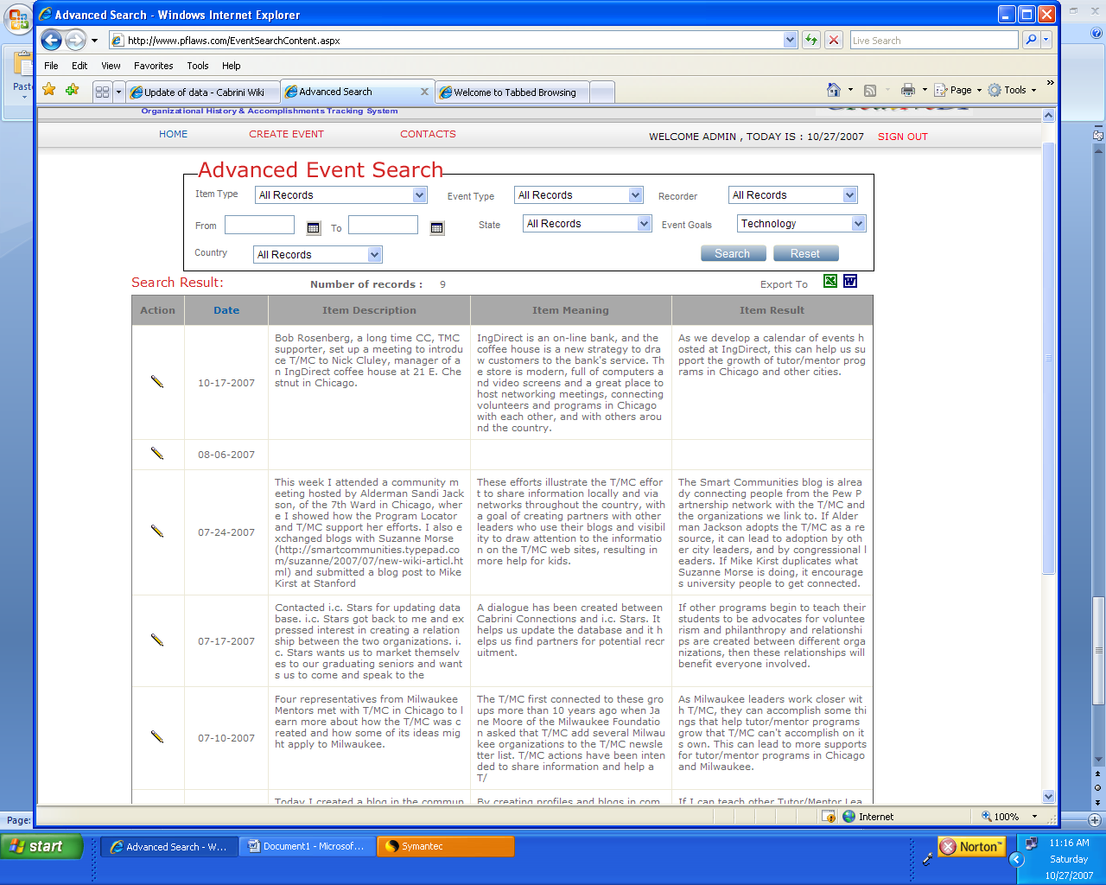
When I search in the Event Type field, I only get 2007 events. However, when I search in Event Type field, I get a search of all years. Can you fix this.

Can I search combinations of one or more search condition, such as date range, event type, Event date and name of recorder?

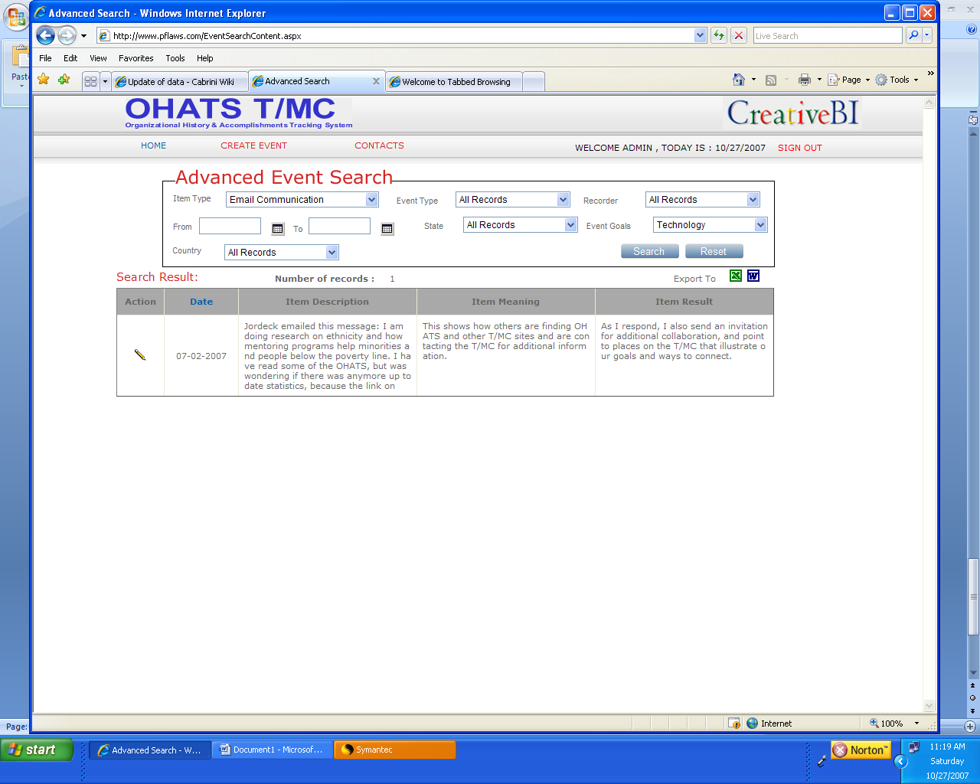
The heading of all pages (once someone has logged in) should included. Home; create event ; search ; metrics; contacts; T/MC web sites
Home should have a drop down menu, with Internal; External; Key Locations; Archives (which you have on the log in page now)
Can you re-order the Advanced Event Search fields
Switch positioning of Event Goal with Item type.

ACTIONS column in search Result – this is confusing
- I’d like to be able to click on this to get a screen that shows event details, similar to what you built into the log in page (see below)
- On the full EVENT DETAILS screen there should be an EDIT DETAILS button, that takes you to the CREATE EVENT screen where you make changes. Only people with permissions can edit.

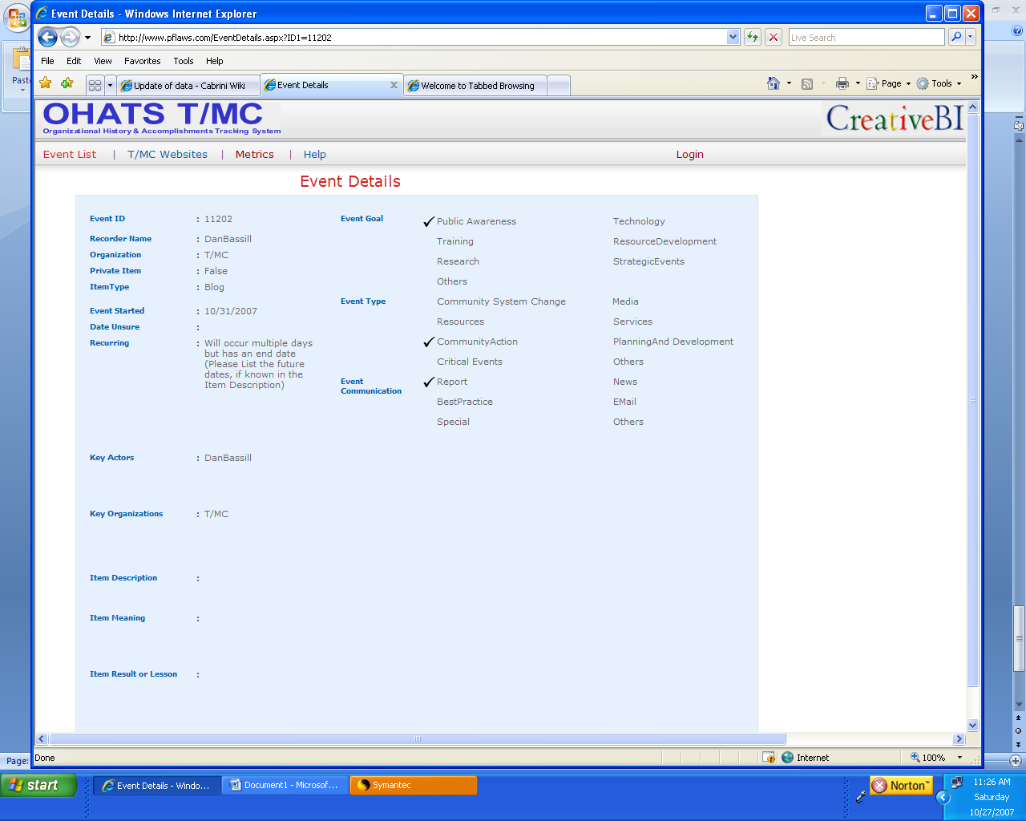

I really like that we can view event details like this. CAN THE EDIT EVENT button be on this page instead of the previous form?

I have the same comment here as on previous page. The search does not seem to bring up all years. Plus I want to be able to search in combinations.

